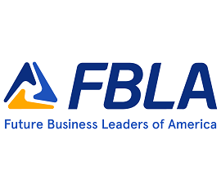
2024 KS FBLA State Pin Contest

Kansas FBLA will be holding a pin design contest for the 2024 NLC in Orlando, Florida. You can use the National FBLA theme Together We Achieve or another theme to depict Kansas FBLA.
Each chapter can submit up to ‘two’ different designs for this contest. The pin can have up to six different colors (black does not count as a color) and when image is resized to 1” it will not be distorted. Save as PDF file and, pease be careful of copyright and it must be original.
The pin design must be submitted by DECEMBER 15, 2023 to State Adviser, Connie Lindell at conniefbla@gmail.com. Please include this entry form with your design(s). Once submitted, the pin designs will then be voted on at all district conferences and announced at the State Leadership Conference in Topeka, Kansas.

Design Members Name(s): ____________________________________________

Name of School: _________________________________________________

Adviser E-mail: _________________________________________________

General explanation of your design and/any symbols on your pin design:

2023 Winning State Pin Design—from Jefferson County

