2024 OUTSTANDING CHAPTER
RECOGNITION AWARD

THIS DOCUMENT MUST BE HONESTLY COMPLETED TO BE CONSIDERED FOR THE OUTSTANDING CHAPTER RECOGNITION AWARD (THE TOP 10 WILL BE RECOGNIZED) AT THE 2024 FBLA STATE LEADERSHIP CONFERENCE AWARD CEREMONY. The purpose of this document is to obtain a better representation of Kansas FBLA’s Top Chapters as an entire chapter and not just as competitive event winners.

- To place in TOP 10 – chapter must have at least 1 individual or team place in an event at 2024 State Leadership Conference
- Your chapter will receive 1 point for every activity.
- The Top 10 schools with accumulated points from winning events will receive the following points. (1st-20 pts, 2nd-18 pts, 3rd-16 pts, 4th-14 pts, 5th-12 pts, 6th-10 pts, 7th-8 pts, 8th-6 pts, 9th-4 pts & 10th-2 pts)
- Activity CANNOT be repeated to gain additional points. The same activity can only appear in ONE SECTION. Example—A Color Run to raise money for the March of Dimes—It must either appear under the March of Dimes Activity Section or Fundraising Activity Section.
- The time frame for eligible Activity: the end of the 2023 State Leadership Conference to the beginning of the 2024 State Leadership Conference.
- WITHIN EACH SECTION, PLEASE NUMBER AND DATE EACH EVENT TO HELP ENSURE PROPER POINTS ARE AWARDED.
- There is a limit of points given for a repeated activity in the same category – i.e. Concession Stand, speaking to Lion’s Club, Athletic Programs, Team photos.
- A chapter submitting this form must have an activity in at least 10 DIFFERENT CATEGORY EVENTS.
- This form must be electronically typed and submitted on March 29 to kansasfblaevents@gmail.com

NO LATE SUBMISSIONS WILL BE ACCEPTED!
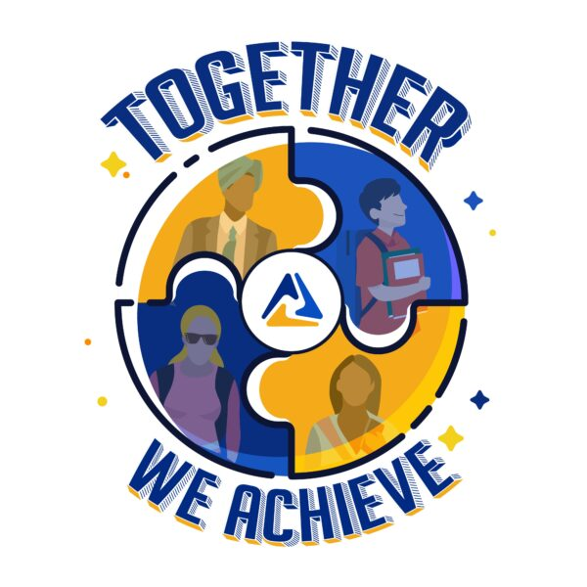

CHAPTER NAME:
CHAPTER ADVISER NAME:
CHAPTER ADVISER EMAIL:

Category Event | List | Point(s)
Accumulated Testing Points from the 2024 State Leadership Conference (The judge will do this)—(1st-20 pts, 2nd-18 pts, 3rd-16 pts, 4th-14 pts, 5th-12 pts, 6th-10 pts, 7th-8 pts, 8th-6 pts, 9th-4 pts & 10th-2 pts)
Community Service Activity
EX – Handed Food Out at the Food Pantry (9/25/22)
Fundraising Activity
(LIMIT of 10 points awarded for repeat activity – i.e. - concession stand)
Leadership Activity
EX – Chapter Meeting
March of Dimes Activity
EX – Sold Baby Feet (9/14/23)
Media Recognition
EX – Article in the Kansas Exchange (9/10/23) (not own Chapter Facebook Account recognition/posts)
Increased or Maintained Membership (Need # of members 2022-23 and # of members 2023-24)
Middle Level Awareness Activity
EX – Welcome Back Dance (8/25/23)
National Program Activity
EXAMPLES: FBLA Week, American Enterprise Day, Job Shadow Day, National Community Service Day, GO GREEN
Membership Drive
EX – Ice Cream Party (9/10/23)
School Service Activity
EX – All School Recycling Collection (9/22/23)
Business Achievement Award Completions
Contributor, Leader, Advocate, Capstone (Provide Student Name, level and business skill or content area if Advocate Level.)

Professional Members
Social Activity
EX – Scavenger Hunt (9/10/23)

2023 National Fall Leadership Conference Attendance (YES or NO) OR
Dallas, TX
Member Presented a Workshop at a FBLA Conference, OTHER than the Kansas Summer Leadership Seminar
(LIST NAME AND WORKSHOP)
State Officer Candidate at the 2024 State Leadership Conference
(LIST NAME(S) AND OFFICE(S))
Submitted a Local Chapter Annual Business Report for the 2024 State Leadership Conference (YES or NO)

Recruited or Reactivated Chapters
(LIST CHAPTER(S))
Promoted FBLA to Other Schools Through Formal Presentations
(LIST SCHOOL(S) AND PRESENTER(S))
Hosted a 2024 District Conference
(YES or NO)
Have a National Officer 2023-2024
(LIST NAME & POSITION)
Have a National Officer Council Member, Regional Board Member or Kansas FBLA Active Membership Council Member
(LIST NAME(S) & TITLE(S))
Corporate Sponsor(s)
List name and $ amount
EX – Solomon State Bank $150 (9/3/23)

Submitted Chapter of the Month Criteria (LIST THE MONTHS SUBMITTED)
Pin design(s) submitted by deadline for the 2024 SLC
Chapter Social Media Account updated regularly
EX – Facebook, Instagram

State Pin design won state pin design at SLC 2023
(YES or NO)
2023 National Leadership Conference
Attendance (YES or NO)—ATLANTA, GA
(Include any awards won or recognitions
received)

OTHER (Description)
Place anything here that you do not feel belongs in the other categories

