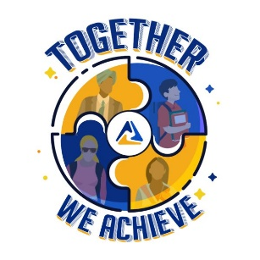
Future Business Leaders of America
Connie Lindell, State Adviser
• 3920 Sophora Street •
Lawrence, KS 66049-7815
• (785) 760-1038 •
conniefbla@gmail.com

November 20, 2023

SUBJECT: 2024-2025 KS-FBLA State Officer Application information

To apply for a Kansas FBLA State Officer position, you must complete and EMAIL or mail the following items by of before December 15, 2023:

1) letter of application (refer to the box below for address and how to ‘address’ the letter)
2) resumé with objective line (limit to two pages)
3) application form, that includes signatures from candidate, adviser, parent, administration
4) picture of candidate in business attire. A ‘head & shoulders’ picture will work.
**Parliamentarian candidates only need to complete the application form

The above items can be emailed, or mailed and must be postmarked by or before:
Wednesday, December 15, 2023

The Letter of Application must be addressed to:
2” Top Margin before Dateline
Current date

Quad Space after Dateline
Ms. Connie Lindell, State Adviser
Double Space before & after; SS paragraphs of letter; DS between, don’t forget to SIGN your letter.
Kansas FBLA
3920 Sophora Street
Lawrence, KS 66049-7815

Dear Ms. Lindell
When applying for an office, a candidate (for ALL offices, even District VP) MUST have completed the ‘Contributor’ Level of the Business Achievement Awards (BAAs) before December 15. A candidate may want to check their calendar to see if you are available to attend the following (required) events in 2024-2025:

- State Officer Interview Saturday, January 6, 2024, Tonganoxie HS, Tonganoxie, KS * Required attendance for candidate & adviser! Depending on weather.
- 2024 District Conference—required attendance, especially if you are a District VP candidate
- 2024 State Leadership Conference April 3-5, Topeka *
- State Board meeting, April 26-27, 2024 Topeka *
- CTSO State Officer Training, June 3-4, 2024, location TBA *
- June 29-July 2, 2024—National Leadership Conference, Orlando, FL *
- Summer Leadership Seminar (SLS)—July 22 or 29, 2024 TBA *
- State Board Meeting, September 21, 2024, TBA -*
- NFLC, Conferences—Locations TBA November 8-9, 15-16, or 22-23, 2024
- State Officer Interview Saturday, January 4, 2025 (TBA) *
*required attendance

Please contact me: conniefbla@gmail.com (785) 760-1038 (cell) if you have any questions.

