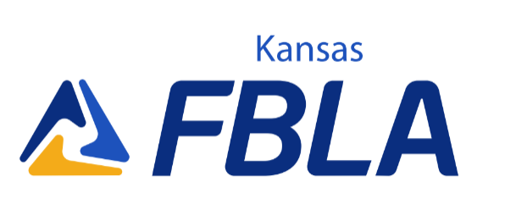
Quality Member Award- FBLA HS Division
The Kansas collegiate division of FBLA has proudly sponsored the Kansas FBLA Quality Member Award (QMA) for over 15 years. To receive the KS FBLA Quality Member Award (QMA), you must complete the requirements listed below. All activities must be FBLA related and completed between March 2023-February 2024. Check the column at the left when completed, and list the month, day, and year that you completed each task (example 3/31/23). Numbers 1-4 are required for consideration; members are highly encouraged to fill out as many activities applicable to them in the ‘optional’ section, and answer the two short response essay questions. FBLA Advisers must sign the form (OR send an email of approval to the FBLA Collegiate State Adviser) to be eligible. Current KS FBLA State Officers or National Officers are not eligible for this award.

Member Name: Member Grade:________________________
Member E-mail: Member Chapter: .
Adviser: . Adviser Signature:_______________________
Required

__ 1. Attend five local FBLA chapter meetings (in person or virtual) in the 2023-2024 year:

__ 2. Recruit two FBLA members:

__ 3. Organize or participate in one project for March of Dimes:
__ 4. List all the FBLA Conferences (in person or virtual) that you have attended while in FBLA (example: Districts, SLS (Summer Leadership Seminar), NFLC's (National Fall Leadership Conference), State Leadership Conference (SLC), National Leadership Conference, etc.)
Optional

Serve as an active member of a committee.
Committee: Date(s) of Participation:
Participate in an FBLA fundraising activity.
Activity: Date:
Participate in a school or community service project (NOT March of Dimes).
Project: Date:
Give a presentation involving FBLA.
Audience/Location: Date:
Participate in American Enterprise Day or FBLA Week project.
Project: Date:
Participate in one of the sections of the Chapter Challenge. Chapter Challenge Section(s):

Quality Member Award- FBLA HS Division

You must complete one short required response essay question and one of the optional essay questions. Each response must be 200-500 words (i.e. at least 200 words per question).

Elaborate on your role in these projects, not only what your chapter has done, if applicable.
The FBLA collegiate state officers will rank the applicants based on their involvement in the above activities and the quality of the short response essay questions (grammar, punctuation, structure, thought process, etc.)

Required Essay Question:
Since FBLA is a lifetime organization that begins with the Middle Level and ends with the Professionals….
“Why do you believe FBLA members should continue their membership in FBLA collegiate when they attend post-secondary education; plus add a statement to answer “Do you think FBLA collegiate would be a good fit for you; explain why or why not?”

*Note: we will not dock or award extra points if you say FBLA collegiate doesn't fit into your plan; it is the purpose to see why FBLA members do or do not join FBLA collegiate once they graduate.

Other Optional Essay Questions (pick one):

Essay Question 1: How does FBLA prepare you for the workforce? Describe FBLA to us like we are a potential member, how does this relate to work ethic, careers, and professionalism?

Essay Question 2: In your opinion, what is the most important part of the FBLA creed? Explain why in detail.

Send the completed and signed form along with your essay in a scanned PDF to:

Janice Akao, Kansas Collegiate FBLA State Adviser
ksadviser.cfbla@gmail.com

Forms must be emailed to Janice by:
February 15, 2024, 5:00 PM

